Lilly Leiran
Collin Hull
English 2010
5 November 2013
Bipolar Disorder With Hypomanic Episodes
“Lilly,” the light flips on, piercing my eyes through my eye lids.
I roll over tiredly, covering my face. “Mom, what are you doing?” I say sleepily and with more than a little irritation in my voice.
“It’s time to get up; you have an appointment this morning,” she says, doing all the things she does to try to annoy me out of bed – jiggling my bed like an earthquake, sticking her fingers in my nose and ears, and smacking my butt.
“Ugh! Mom, stop it!” I exclaim, rolling onto my back and covering my face with the blanket. “And turn the lights off, what’s wrong with you?”
“We have to leave in thirty minutes, get up. And you should take a shower,” my mom says bouncing out of the room, and cruelly leaving the lights on.
I pull the covers tighter over my head and close my eyes again, in moments I’m back asleep until all of the sudden it’s thirty minutes later and the covers are being yanked off. I’m assaulted by the cold January air that seeps through my bedroom floor, “Ah!” I exclaim as my mom literally yanks my legs off the bed and pulls my body into a sitting position.
“What are you going to wear?” she asks bending over to search through the mounds of clothes on my floor.
I make a sort of sleepy moaning sound and begin collapsing back onto my back; the bed is so comfy...
“Oh no you don’t!” she exclaims and pulls me back up but this time all the way to my feet. My eyes are still closed and I’m more than half asleep still but I can’t help thinking how she doesn’t look as strong as she is. I can picture her even with my eyes closed as they are now; she’s got this little blonde bob stiff with hair spray and straight across bangs, brown eyes, and a small gap between her two front teeth but otherwise her smile is perfect and pure white. Every day she wears high heels and puts make-up on, you’d never guess she could yank me to my feet like that but she’s five feet two inches of pure will power.
“Mom!” I exclaim whining loudly, “why are you doing this to me?” I whimper like a child about to throw a fit, even though I’m sixteen.
“You have an appointment with the psychiatrist. Here,” she says, handing me a bra. “Put this on.” I give another whimper as I sit back down on the bed to put the bra on, my eyes are still closed but I’m upright so this is progress. I realize as I’m putting it on, fumbling in my sleepiness with the clasp, that I haven’t had a bra on in at least week – probably more like two if I’m being honest – but I haven’t even left my room for more than ten minutes in days either so what would have been the point? My mom hands me a cute shirt and jeans, she then turns away to get me some socks out of the drawer and I throw the cute clothes on the floor in favor of a hoodie and some sweat pants. I lay back to put them on, sloooowly.
When I sit up dressed, sort of, my mom gives me a dubious look as she inspects my outfit. “I have a bra on.” I say defensively. She just looks at me and hands me a pair of socks. I put them on then slippers after and we’re out the door, slowly.
I’m still drowsy as I sit in the car; the sleep won’t leave my eyes no matter how much I rub them so, instead, I decide to just close them and get 20 more minutes of sleep on the way to the doctor’s. My mom wakes me when we arrive and I lean on her as we walk in, I’m so tired. God am I sick of being tired!
But that’s been my life for the last three months, tired. I’m so sick of being tired and of hating myself for being so desperately tired, too tired to go to school or hang out with people or do the homework I am still expected to do, sometimes I am too tired to even eat or drink or shower. I’m pretty sure I haven’t showered in a couple of days but what’s the point? And boy am I sick of doctor’s offices and hoping there’s something medically wrong with me so I can be fixed, so I’m not just going crazy.
But that must be it, I’m crazy, it’s the only answer left. I’ve been to every doctor we could think of, had every blood test that could possibly make sense, and even chest x-rays. Every medical option had been exhausted and they found nothing. Nada. Zilch. Which I guess I should be relived about but I’m not, because now it has come to this. Psychiatrist. It feels like a dirty word that no one should say aloud, like masturbation or incest. Everyone knows it exists but it’s not something people talk about. It’s not a psychologist, the ones who deal with normal people problems. No, it’s a psychiatrist, the ones who deal with the real crazies and I guess that’s me now.
I look over at my mom as we get on the elevator and she looks determined – as always – and maybe a little scared. She has been my angel through all this. Three years of this and she never gives up, never stops. I can’t imagine how much all these blood tests and specialists cost, not to mention the work she’s had to miss for the appointments and the stress of having a daughter like me, semi-perfect one day and bonkers the next.
Ding! The elevator door opens and I think, here we go.
My psychiatrist, Carmella, a well under five feet tall Asian woman who laughs like a hyena and “mhmm…”s approximately every 5 seconds and has at least 20 Buddha statues throughout the office asks me questions and give me surveys for the next two hours. She quickly determines that depression is a factor, uh… ya think? Just look at me, I am wearing sweat clothes and slippers to the doctor’s office, I obviously haven’t had a shower in days, I’m minimally responsive, and I have hardly left my bed for months. I sleep about 14 to 18 hours per day and when I’m not sleeping I just sit there in the dark and stare at the ceiling, I feel like everyone hates me especially me, I’m irritable, and I quit dance, my favorite thing in the whole world. My mom and I look at each other and pass a silent “Duh!” between us.
Then Carmella tries ADD on for size since I’ve had trouble focusing and getting to sleep because of racing thoughts and my big brother has ADHD. I match some, but not all of the characteristics. “Mhmm, mhmm, mhmm…” she says then pulls out the questionnaire for Bipolar Disorder and everything matches.
The words “You have Type II Bipolar Disorder with hypomanic episodes” stop me in my tracks. Bipolar? What? What does that even mean? I feel like I have just been rubber stamped for the loony bin, like my life is O-V-E-R!
After that I can see their lips moving, know that my mom and the psychiatrist are still speaking to each other, and to me, but all I can hear is a ringing in my ears. I hold out my hand when the psychiatrist hands over a prescription and look at it. But my vision is narrowing to a pin hole, just like my future. Just hours ago I could have been anyone or done anything but now…? How will I ever find any man who would want to love me? Or even any friends who would accept such a damaged person in their life? Now, I tell myself, I can’t have children because I would never want to pass this plague onto my offspring. And what jobs will I be eliminated from because of this? I am just damaged goods, a mistake. If I were a candy bar in a factory I’d just be thrown away, they couldn’t send me out the way I am they would certainly have a dissatisfied customer. I’m defective and I am slipping away down a dangerous slope, I can feel the despair taking hold… all I want is to go in my room, turn off the lights, cry, and then sleep, forever.
On the drive home I turn my head away from my mom and cry, hoping she can’t see. She babbles on about how now that we know what’s wrong we can simply deal with it and everything will be okay. She seems so sure and I desperately want to believe her but I don’t. Everything is not okay.
I spend the next three days in my bedroom, lights off, crying and trying to decide if this is really the end of my life or not, taking the pills given to me by my psychiatrist and praying for them to work and work quickly. Eventually the medicine begins to work and I find the strength to go on, go back to school. At some point I also go back to counseling and as I gradually learn more about the illness. I also learn that the prognosis is no so grim as I had initially anticipated. But what was I to think in that moment I was diagnosed? I only knew what little I knew at the time of diagnosis, which was nothing. I didn’t understand what it meant for someone to have Bipolar Disorder, and what the heck is a hypomanic episode?
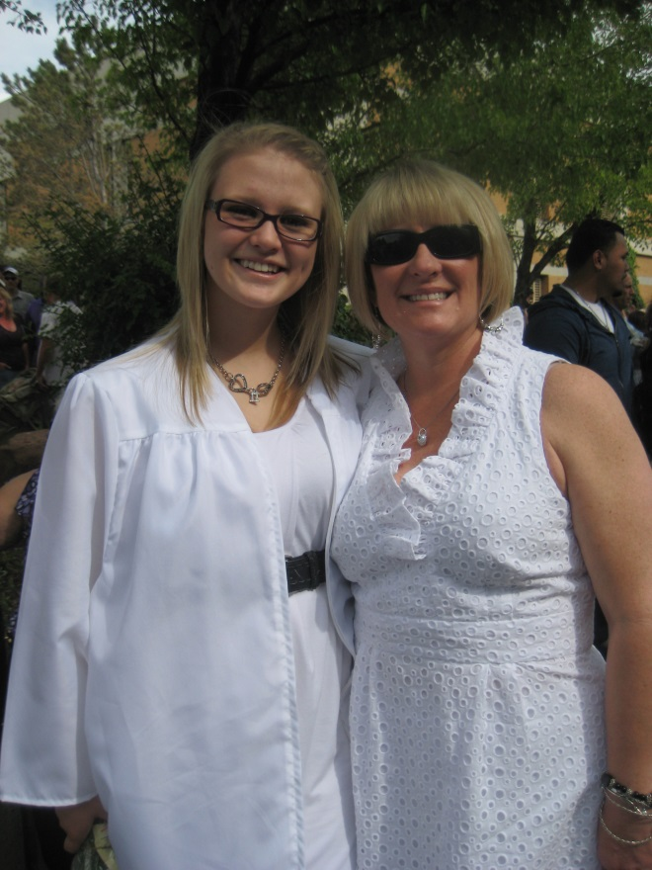
Six months later I was graduated a year early from high school at the age of 16 and I was looking forward to going to college in the fall. I was even happy. All it took was some education, medication, and hard work in therapy and my life was better. It wasn’t over for me; life was full of opportunity and promise again.
In the first weeks after receiving my diagnosis I was desperate, hopeless, confused, and scared. What I felt in that moment and for weeks after receiving my diagnosis is why I think it is so important for there to be required education in schools for young people about what mental illnesses really are and what they mean for those who have them because once I gained that knowledge I became hopeful again. Once I knew what I was dealing with I became relieved that at least I knew what was happening and now I could deal with it in a more productive and healthy way.
Image 1: Me and my mom at my graduation ceremony in June of 2011. I was 16, graduating early from high school, and looking forward to college. You’d never know the struggle I’d been through just six months ago.
I believe this mental health education needs to occur in early adolescence because according to Marta Hauser and Christoph Correll in their article in the Canadian Journal of Psychiatry 50 to 67 percent of patients with Bipolar present before the age of 18 (23). That means that over half of the people who will have Bipolar Disorder will develop it before adulthood. I was 13 when I started presenting symptoms and 16 when I was diagnosed and that is a fairly small amount of time between onset and diagnosis compared to most people. According to Jane H. Roberts and Paul M. Bernard in an article in Mental Health and Family Medicine the average delay between onset and diagnosis is 5 to 15 years (116). I got lucky, having such a strong mother who is not afraid to advocate for me and do whatever it took to help me feel better but a lot of young people don’t have that.
It is so important for this information to be on kid’s radars before the symptoms arise, before they are diagnosed, before they have to feel so scared and alone. Suicide rates are extremely high among pediatric bipolar patients, along with substance abuse rates, and the heredity of mood disorders is among the highest of all psychological disorders so it can be watched for among those who are at risk. We can help those who will inevitably be diagnosed be prepared to receive that diagnosis and we can help them too by trying to remove some of the stigma from mental illness by educating the general population about what it truly means to be mentally ill, removing the myths, and how to be mentally healthy.

Works Cited
Hauser, Marta, and Christoph U. Cornell. “The Significance of At-Risk or Prodromal Symptoms for Bipolar I Disorder in Children and Adolescents.” Canadian Journal of Psychiatry 58.1 (2013): 22-31. Academic Search Premier. Web. 6 Oct. 2013.
Roberts, Jane H., and Paul M. Bernard. “’Can he have the test for Bipolar, doctor? His father has it.’: Exploring the Potential of General Practitioners to Work with Children and Young People Presenting in Primary Care with Common Mental Health Problems – A Clinical Initiative.” Mental Health in Family Medicine 9.2 (2012): 115-123. Academic Search Premier. Web. 6 Oct. 2013.

