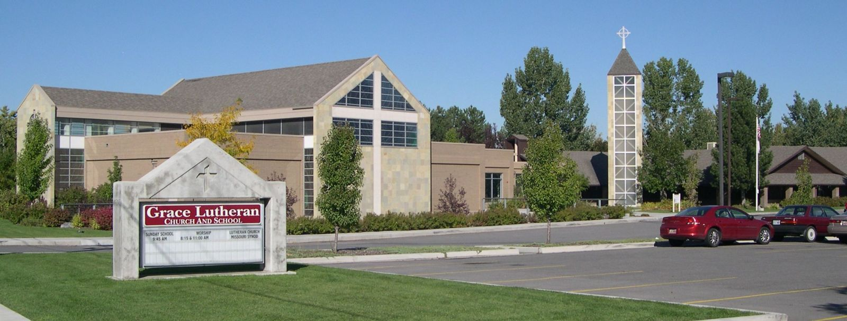
Lilly Leiran
Dave Schuler
Anthropology 2120
1 December 2013
Grace alone, Scripture alone, Faith alone
I chose to do my report on Grace Lutheran Church and School in Sandy, Utah, a church of the Missouri Synod of Lutherans. I chose this faith because I wanted to take a look at a church of the same faith I grew up in from an Anthropological perspective and see what I may have missed while I was assuming it was all “just the way it is” when I was little.
The Lutheran faith is the oldest of the protestant religions, started by a man named Martin Luther. Martin Luther was a German monk in the 16th century; he spent the first 30 years of his life in anguish because he could see what a sinner he was, he tried to do everything he could to relieve himself of this sin. He became a monk and studied the Bible and did everything he could to relieve himself from the sin he felt crushing him but he found no relief. Finally in 1517 he began seeing that the Catholic Church was full of indulgent and unnecessary behaviors. In fact he found 95 things he believed were wrong with the church, practices that contradicted the Bible, and nailed them on the door of the church in his town. He did not mean to separate from the church, at least not originally, he only wanted reform. Eventually he was excommunicated for speaking out against the church but that didn’t stop him from sharing his new-found beliefs and when he did in neighboring countries he started to gain a following and soon the Lutheran church was born.
The Lutheran faith, like all Christian denominations, focuses on the teachings of Jesus but through the lens of Martin Luther. Pastor Brooks of Grace Lutheran church said in his “Reformation” sermon that Luther’s “Aha!” moment came when he was studying the book of Psalms and he realized it was Jesus speaking when David wrote, “My God, my God, why have you forsaken me?” Luther was shocked when he realized that Jesus had felt the same things he did, alienation and suffering due to the distance from God. He didn’t understand why God would make Jesus suffer like that until he realized this was God’s plan for saving him. He realizes that Jesus had to know humanity’s suffering in order to have compassion and save our souls for God. He saw and found comfort in the realization that God had a personal interest in his life, that the whole time he had had a plan to save him from his sin. That God was so invested in the relationship between anyone human and himself that he would make the sacrifice of his only son to save humanity. Pastor Brooks says that this all means that Jesus’ story, is our story. It must become our story.
During the formation of his new beliefs Luther thought that not only were some rituals and prescribed practices of the current church unnecessary but they actually impeded the journey to salvation rather than aid in it. Though he rejected many of the Catholic beliefs and practices he kept anything that didn’t directly go against the teachings of the Bible; that’s why Lutheran churches often have the look and feel of a Catholic church. This was somewhat unusual in the Protestant movement because most threw out anything that didn’t come directly from the Bible.
Lutheranism is based on the teachings of Jesus, like all Christian faiths, which are messages of acceptance, love, kindness, generosity, and faith in God the father, Jesus the son, and the Hold Spirit, a guiding force of faith in the lives of humanity. This essay was named “Grace alone, Scripture alone, Faith alone” because that’s the statement Grace Lutheran’s website uses to describe their faith. They then go on to explain the phrase in its three parts. “Grace alone” means that God loves us even though humanity are sinners who don’t deserve his love, he cares about us so much that he sent his only son to suffer for the sins we would all eventually commit and love the unlovable to the point of ultimate sacrifice. “Scripture alone” means that the Bible, which is God’s word, is the only doctrine by which humanity should live their lives; through it humanity will find salvation in Jesus. “Faith alone” means that when a human discovers the truth that Jesus has suffered so humanity will be forgiven for their sins that they accept and appreciate the sacrifice and will thereby live out eternal life with God in heaven. These are the basics of the Lutheran Church according to Grace Lutheran Church and School.
One of the first important rites of passage in the Lutheran faith is that of baptism. Baptism is the symbolic washing away of a person’s sins. Lutherans practice both infant baptism and adult believer baptism. In an infant baptism a parent will bring their child into the church and have them blessed by the pastor, in this ritual the parents will select a godfather and godmother for the child then the pastor will splash blessed holy water on the child’s head while asking God to “bless this child in the name of the father, the son, and the holy spirit. Amen.” An adult baptism is the same thing except with an adult rather than a child.
There is also a secondary text used for a rite of passage called “Catechism” which is a class designed to teach young people (ages 12-14) their duties in life as a Lutheran, after the completion of this class a young Lutheran can take communion during worship services. The book I looked at was called “Luther’s Small Catechism with Explanation.” In this book it teaches about the Ten Commandments, the Creed, baptism, confession, sacrament of the alter, daily prayers, and duties. It teaches about each of these aspects of the religion with Bible verse and with a modern language explanation of its significance. There are also duties that need to be completed throughout the course of taking the Catechism class, such as participating in alter duties, in order to receive communion.
Lutheranism originated in Germany with Martin Luther and is now the main religion there along with many nearby Scandinavian countries and it is even the official religion of Norway, Sweden, Iceland, and Denmark and an 81% majority in Finland. Along with many other faiths, Lutherans moved to America in the 17th Century and have spread throughout the United States since.
I attended three Sunday morning worships at Grace Lutheran Church and School, the first was on the Reformation, the second on Angels, Archangels, and all the Company of Heaven, and the third was called sing a new old song. It was strange going back to church after all these years, I remembered much of what happened but looking at it all through the eyes of questioning rather than acceptance or rejection was very different. I found myself seeing it as more beautiful and poetic than I ever had before and I liked it.

Schedule of Research
Oct 27, 2013 – Visit to Grace Lutheran Church and School (11 o-clock service) 1 & ½ hours
Sermon called “Reformation” when Martin Luther found his salvation and, wanting to share the same message with everyone else, broke away from the old Christian Church.
Nov 3, 2013 – Visit to Grace Lutheran Church and School (11 o’clock service) 1 & ½ hours
Sermon called “Angels, Archangels, and All the Company of Heaven” talking about Saints and how even the most normal, everyday people can be saintly; more saintly than some of God’s apostles even.
Nov 11, 2013 – Online Research Day 4 hours
I researched Martin Luther and the origins of Lutheranism also the specific beliefs of Grace Lutheran Church and School.
http://www.religionfacts.com/christianity/denominations/lutheranism.htm
http://www.gracesandy.org/beliefs.cfm
Nov 17, 2013 – Visit to Grace Lutheran Church and School (11 o’clock service) 1 & ½ hours
Sermon called “Sing an Old New Song” the pastor talked about how we are the creators of our own fate, we create sin so we create death and suffering and all the bads in our world and Jesus is the answer.
Dec 1, 2013 – Online and Book Research Day 3 hours
Studied Catechism and Baptism and tried to find the answers to my questions.

Methods
Originally I had thought of doing Judaism or Sikhism but then I came up with the idea of taking an Anthropological look at the religion I grew up in and decided that would be really interesting. Lutheranism is not my current religion so I thought it was an acceptable choice.
For this field research I went into it trying to be very unbias and trying to look at from the point of view I am now in, outsider, because I am no longer a member. It was weird but surprisingly easy to take that outsider point of view. I tried to look at the things around me and see them as if I’d never seen them before, as if I didn’t understand the reasoning behind any of it and I ended up realizing there were things I honestly didn’t know why they did them. Like keeping the lighter stick lit while walking it in to light the Jesus candle and I wondered why there was a railing along the raised platform where the alter is.So I tried to research those things but unfortunately I couldn’t find the answers online. If I had had more time I would have e-mailed the pastor of the church but unfortunately I didn’t.
It was an interesting experience to look at Lutheranism in that way and I had fun with the project.

